Name: Saleh Ahmad alheeh

ID:201614721

//Class Server @@@@@@@@@@@@@@@@@@@@@@@@@@@@@@@@@@@@@

using System;

using System.Net;

using System.Net.Sockets;

using System.Text;

namespace ConsoleApp2

{

class Server

{

public static void Main()

{

Socket Server = new Socket(AddressFamily.InterNetwork,

SocketType.Stream, ProtocolType.Tcp);

try

{

IPAddress myip = IPAddress.Parse("192.168.100.10");

IPEndPoint localEP = new IPEndPoint(myip, 4400);

Server.Bind(localEP);

Server.Listen(10);

Console.WriteLine("Waiting for a client...");

Socket clientSocket = Server.Accept();

IPAddress clientip = ((IPEndPoint)clientSocket.RemoteEndPoint).Address;

int port = ((IPEndPoint)clientSocket.RemoteEndPoint).Port;

byte[] bytes = new Byte[1024];

string RDAta = null;

int numByte;

Console.WriteLine("successful connection from : {0} ", clientip);

RDAta = " Wellcome " + clientip + ":" + port;

Console.WriteLine(RDAta);

numByte = RDAta.Length;

bytes = Encoding.ASCII.GetBytes(RDAta);

clientSocket.Send(bytes, numByte, SocketFlags.None);

while (true)

{

numByte = clientSocket.Receive(bytes);

RDAta = Encoding.ASCII.GetString(bytes, 0, numByte);

Console.WriteLine(RDAta);

clientSocket.Send(bytes, numByte, SocketFlags.None);

if (numByte == 0)

break;

}

clientSocket.Close();

Server.Close();

}

catch (Exception e)

{

Console.WriteLine(e.ToString());

}

}

}

}

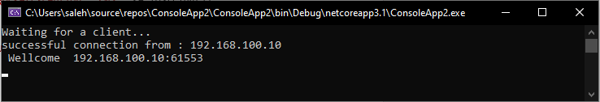Output :

//END OF CLASS@@@@@@@@@@@@@@@@@@@@@@@@@@@@@@@@@@@

//Class Client@@@@@@@@@@@@@@@@@@@@@@@@@@@@@@@@@@@@@@@@@

using System;

using System.Net;

using System.Net.Sockets;

using System.Text;

namespace ConsoleApp1

{

class Client

{

public static void Main()

{

Socket Client = new Socket(AddressFamily.InterNetwork,

SocketType.Stream, ProtocolType.Tcp);

try

{

IPAddress myip = IPAddress.Parse("192.168.100.10");

IPEndPoint remoteEP = new IPEndPoint(myip, 4400);

Client.Connect(remoteEP);

byte[] messageReceived = new byte[1024];

// We receive the messagge from Server

int byteRecv = Client.Receive(messageReceived);

Console.WriteLine("Messagge from Server :"+ Encoding.ASCII.GetString(messageReceived, 0, byteRecv));

while (true)

{

Console.Write("Enter message for server or exit to stop: ");

String input = Console.ReadLine();

if (input == "exit")

{

break;

}

// Creation of messagge that we will send to Server

byte[] messageSent = Encoding.ASCII.GetBytes(input);

int byteSent = Client.Send(messageSent);

// Data buffer

messageReceived = new byte[1024];

byteRecv = Client.Receive(messageReceived);

Console.WriteLine("Echo -> {0}",Encoding.ASCII.GetString(messageReceived,0, byteRecv));

}

Console.WriteLine("Stopping client");

Client.Close();

} // Manage of Socket's Exceptions

catch (ArgumentNullException ane)

{

Console.WriteLine("ArgumentNullException : {0}", ane.ToString());

}

catch (SocketException se)

{

Console.WriteLine("SocketException : {0}", se.ToString());

}

catch (Exception e)

{

Console.WriteLine("Unexpected exception : {0}", e.ToString());

}

}

}

}

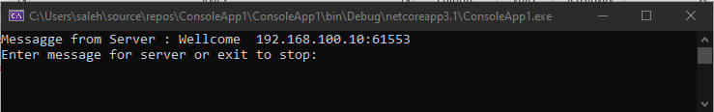Output :

//END OF CLASS@@@@@@@@@@@@@@@@@@@@@@@@@@@@@@@@@@@@@@@@

Output :

